The following text is an excerpt taken from John Belton’s book entitled American Cinema/American Culture

*The Star System*

THE MECHANICS OF STARDOM

#### Making Stars

##### Exposed Artifice: Singin’ in the Rain

In the late 1920s, it was estimated that over 32,250,000 fan letters were received each year by movie stars in Hollywood. From the mid-1930s through the early 1950s, over 500 journalists and newspaper correspondents gave Hollywood as their dateline, generating more than 100,000 words per day about the film industry and making Hollywood the third largest source of news information in the country, lagging behind only New York and Washington. Most of that news concerned the public and private activities of movie stars.

Though motion pictures may have been an industry, the general public has always tended to see Hollywood less as a factory town than as a place where royalty resides. Indeed, few eyebrows were raised when screen stars such

■ ■ ■ ■ ■ **87**

as Pola Negri, Gloria Swanson, and Grace Kelly married European counts, princes, and even kings. Stars inhabit a different world from the rest of us and live by different rules. To paraphrase Lina Lamont (Jean Hagen) in *Singin’ in the Rain* (1952), stars are not people. They are celestial bodies.

Convinced by the media of her own stardom, Lina (quoting a newspaper puff piece) explains that she is a “shimmering, glowing star in the cinema firmament.” But Lina, alas, is not a real star; she does not radiate her own light but merely reflects the light cast on her by others. Her image as a star has been carefully fabricated. It is partly the product of studio press releases, which are reprinted verbatim by the media and consumed without question, not only by the public but by Lina herself. And it is partly the product of film technology that functions to conceal her flaws. Though Lina may look like a star, she does not sound like a star—her shrill, lower-class voice lacks refinement and fails to match the glamour and sophistication of her appearance.

This imperfection, which the silent cinema easily ignored, threatens to betray her when she is forced to speak in the talkies. Her image, however, is preserved when another actress, Kathy Seldon (played by Debbie Reynolds), dubs her, substituting her own voice for Lina’s in all of Lina’s dialogue and song sequences. Lina’s phoniness is ultimately unmasked, however, when the curtains are drawn back to disclose to the public part of the previously invisible machinery that has made Lina a star; we see Kathy (Reynolds)—now revealed as the real star—singing the film’s title song in the background as Lina pathetically lip-syncs the lyrics in the foreground.

In the opening sequence of *Singin’ in the Rain,* a radio columnist (Dora) interviews stars attending the preview of a new Lockwood and Lamont picture. Dora’s presence indicates, in part, the role that the media play in Hollywood’s construction of stardom. She becomes the willing vehicle for the transmission of Don Lockwood’s exaggerated reconstruction of his past to the listening public. Yet again, the film exposes the artifice involved in the construction of stardom through a mismatch of voice and image.

Don’s duplicity differs from that of Lina’s in one crucial way, however. Here, we *see* the truth—Don’s less than glamorous personal history—while we *hear* the official, sanitized studio biography, which paints a far more elegant portrait. With Lina, the audience has been tricked into forming a certain set of expectations (into assuming her perfection as a star)— expectations that are then revealed to be incorrect. With Don Lockwood (Gene Kelly), there is no deception because his verbal construction of his image is simultaneously undercut by what we see on the screen. Our knowledge of the truth turns us into his allies and makes us complicit in his playful manipulation of the press. At the same time, the images reveal Don to be hardworking, forthright, and unpretentious—unlike Lina, who emerges as a self-centered prima donna.

Don Lockwood has concocted a charming tale, carefully tailored to project a dignified image that matches the elegance of his onscreen roles. The story he tells is designed for the consumption of not only the radio gossip columnist but also the public, whose fascination with stars drives the economy of two interrelated industries: it draws cash customers to the box office, and it supports the fan magazines (which can be seen in the hands of members of the crowd waiting for the arrival of stars outside the preview of the new Lockwood and Lamont film) and other popular publications that seek to satisfy the public’s almost insatiable appetite for news about stars.

##### Stars, Fans, and Profits

Indeed, it was a film studio that gave birth to the first fan magazine. In 1911, Vitagraph’s head of production, J. Stuart Blackton, launched the *Motion Picture Story Magazine,* the first film magazine designed for a general readership, which publicized Vitagraph’s players and recent releases. Carl Laemmle at Universal followed suit in 1913 with *Moving Picture Stories.* The independently produced *Photoplay,* which was published once a month from 1911 to 1980 and enjoyed a circulation of more than 2 million in the 1920s, took up where the studios left off, providing photo-illustrations of the stories of films and feature articles on film stars. Major fan magazines of the sound era—such as *Modern Screen,* *Photoplay, Silver Screen,* and *Movie Stars*— enjoyed wide circulation (in 1950, *Photoplay* had 1.2 million readers) and furnished, through their probes into the off-screen lives of movie stars and their rehashes of studio press releases, free publicity for the studios, which, in turn, indirectly supported a number of these publications by advertising heavily in them.

Producer Samuel Goldwyn would have had us believe that “God makes the stars. It’s up to the producers to find them.” God, however, has little to do with it. The industry that makes motion pictures also manufactures movie stars, with the aid of the press and other media—movie stars who have played and continue to play a crucial economic role in the history of that industry. In a business in which each new picture is an unproven commodity, the presence of an established star guarantees a certain return on the high-venture capital invested in a film. Since a star’s name on the marquee drew audiences, it was to the advantage of the studios to perpetuate the star system.

The star provides the studio with a tangible attraction, an image that can be advertised and marketed, offsetting the less tangible qualities of the story, direction, acting, art direction, costume design, and overall studio style. Though these latter elements can be marketed as well, they rarely achieve the identifiability of the star and cannot, in themselves, guarantee that a film will make a profit.

Mary Pickford’s popularity (she was receiving 18,000 fan letters per month in 1919) not only ensured the profitability of her pictures but enabled her studio, Paramount, to sell its other, non-Pickford films as well, instituting a system of block booking and blind bidding that was forced on exhibitors who wanted to rent Pickford’s films (see Chapter 4, “The Studio System”). Years later, Mae West, the buxom burlesque and vaudeville performer who gave new meaning to the art of sexual innuendo through her double entendres and her tongue-in-cheek delivery, was credited with saving Paramount when it went into receivership and was taken over by its creditors in 1933. M-G-M owed its survival during the Depression to its stable of stars, which included Greta Garbo, Joan Crawford, Clark Gable, Marie Dressler, Norma Shearer, Mickey Rooney, Judy Garland, and Spencer Tracy; while the youthful singing star Deanna Durbin is said to have rescued Universal in the recession of 1938.

#### Star Power

Stars can save studios because stars sell films. When the investment firm of Kuhn, Loeb and Company decided to bankroll Paramount in 1919, its decision was based, in large part, on the studio’s roster of stars, which included Gloria Swanson, Douglas Fairbanks, William S. Hart, and Pauline Frederick. Stars were assets that the studios could take to the bank. Some major stars even took themselves to the bank, forming their own studio. In late 1919, Hollywood’s premier stars—Mary Pickford, Douglas Fairbanks, and Charles Chaplin (along with “star” director, D. W. Griffith)—formed their own company, United Artists, to distribute their films. But, for the most part, from the 1920s to the 1950s, the studios “owned” the stars, who were bound to them through multiyear contracts. As that system of contracts started to crumble in the 1950s and 1960s, the stars began to assume more and more power in the marketplace. In 1969, in a gesture that recalled the formation of United Artists, a handful of major stars (including Barbra Streisand, Sidney Poitier, and Paul Newman) created First Artists Production Company to finance the production of their films. These stars were soon joined by Steve McQueen and Dustin Hoffman, but the company was unable to generate enough income to finance subsequent films. It effectively went out of business in 1982 after releasing such films as *The Getaway* (McQueen, 1972), *The Life and Times of Judge Roy Bean* (Newman, 1972), *Uptown Saturday Night* (Poitier, 1974), and *A Star Is Born* (Streisand, 1976).

The power of the stars in contemporary Hollywood is reflected in the focus of entertainment journalism, ranging from daily syndicated television shows such as *Access Hollywood* and *Entertainment Tonight* to weekly magazines such as *People* and *Entertainment Weekly.* News about stars is headlined on such TV shows, and photographs of stars dominate the covers of these magazines. Until 2003, *Premiere* magazine published a list of “the 100 most powerful people in movies.” Though the top 10 tend to be the CEOs of production companies and star producer-directors (such as Steven Spielberg and George Lucas), more than a third of the exclusive 100 are stars, ranging (in 2003) from Tom Hanks (no. 13) to Tom Cruise (no. 14), Mel Gibson (no. 15), Julia Roberts (no. 16), Jackie Chan (no. 94), Halle Berry (no. 96), Colin Farrell (no. 98), and Kate Hudson (no. 99). People on the power list can get pictures made; their pictures make money; and, because their pictures make money, top stars such as Hanks, Johnny Depp, Leonardo Di Caprio, Will Smith, and Roberts can command per-picture fees of $20 million as well as percentages of the box-office gross.

As Mike Sullivan in *Road to Perdition,* Tom Hanks goes against type to play a mob hit man.

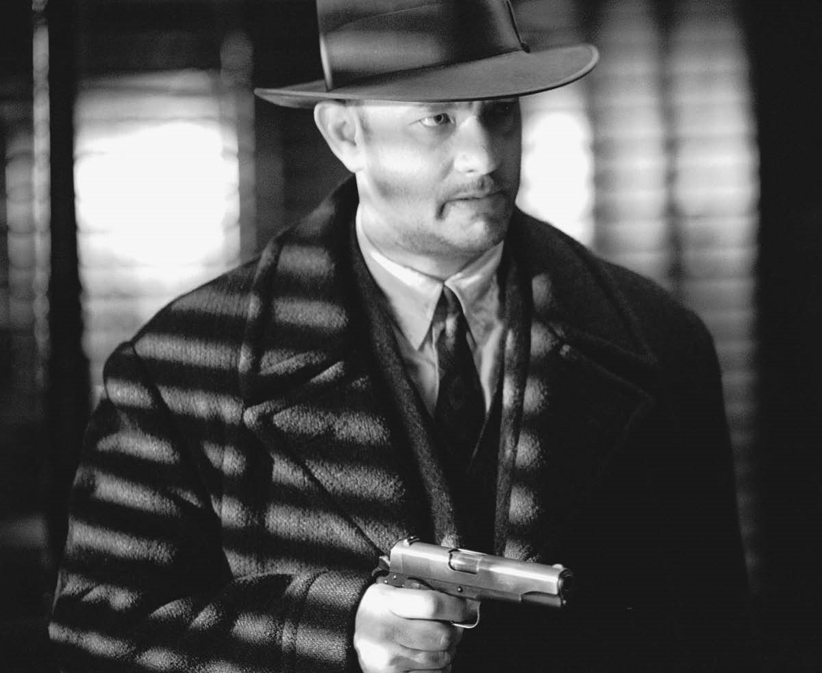

© Dream Works, Courtesy of Everett Collection

##### Tom Hanks: A Case Study

Tom Hanks’s films make money; Hanks is one of only three stars who has appeared in seven consecutive blockbusters that have earned over $100 million each (the other two stars are Tom Cruise and Will Smith). Seventeen Hanks films have grossed over $100 million each. The thirty-six films in which he has appeared or done voice-overs (as of June 2011) have grossed over $3.6 billion, averaging out to over $107 million each. But Tom Hanks is also a star whose talent as an actor has repeatedly been recognized by various institutions in the film industry. Highly respected by his peers, Hanks won back-to-back Academy Awards for Best Actor for *Philadelphia* in 1993 and *Forrest Gump* in 1994. He has also won four Golden Globe Awards, as well as awards from the Los Angeles Film Critics Association and the Screen Actors Guild. Like a number of other contemporary stars, Hanks got his start in film through his apprenticeship on a successful TV series. But unlike Halle Berry (*Knots Landing*), Jim Carrey and Jennifer Lopez (*In Living Color*), George Clooney (*ER*), Leonardo DiCaprio (*Growing Pains*), Eddie Murphy and Mike Myers (*Saturday Night Live*), Will Smith (*Fresh Prince of Bel Air*), John Travolta (*Welcome Back, Kotter*), and Bruce Willis (*Moonlighting*), Hanks’s rise to stardom began by his dressing up as a woman on *Bosom Buddies.* Hanks’s career can be charted in terms of a sexual trajectory from the amiable, soft, sensitive, quasi-feminized, curly-haired youth in his films of the 1980s to the older, harder, more masculine figures he played in the 1990s. The curly-headed youth surfaced in a string of 1980s comedies, from his first hits in *Splash* (1984), *Bachelor Party* (1984), *Volunteers* (1985), and *The Money Pit* (1986) to his first megahit, *Big* (1988). In *Big,* Hanks played a 13-year-old kid trapped in the body of a 35-year-old man, a role that captured the boyish innocence and essential sweetness of his roles in this period. To some extent, this Hanks recalls the all-American earnestness of Harold Lloyd (without the athleticism), though Hanks is clearly no clown. He is a straight actor who plays multidimensional characters who possess a certain comic aspect.

In *A League of Their Own* (1992), in the minor role of Jimmy Dugan—a former baseball great forced into retirement due to injuries who has hit the skids, taken to alcohol, and been reduced to coaching in a women’s baseball league—Hanks refashioned his image from a kid with a future to a man with a past. His character’s insistence that “there’s no crying in baseball” echoes his gruff behavior but masks an inner, repressed sensitivity to his players’ needs. Subsequent roles as veteran astronaut Jim Lovell in *Apollo 13* (1995), the battle-fatigued marine captain John Miller in *Saving Private Ryan* (1998), death-row prison guard Paul Edgecomb in *The Green Mile* (1999), and mob hit man Michael Sullivan in *Road to Perdition* (2002) present a world-weary figure who is no stranger to disappointment, failure, physical pain, and self-doubt. If, in *Big,* Hanks is a kid in the body of a man, in *The Green Mile* he turns out (in the frame story) to be a 100-year-old man in the body of an 80-year-old. In both *League* and *Perdition,* Hanks plays against type; indeed, in *Perdition,* he plays a cold-blooded killer. But his character in *Perdition* nonetheless resembles that of earlier Hanks characters. Hanks has been described as an American everyman. That description fits him in the sense that his films are modern morality plays in which he emerges as the moral compass whose behavior exemplifies an internalized and intuitive adherence to an abstract, unwritten set of moral guidelines. Characters around him—for example, the members of his platoon in *Ryan*— do their duty inasmuch as they do what is necessary for the mission; they play by the book. Hanks’s character seems to be guided by an inner sense of what he *must* do and he does it. When he breaks the rules (and the law) in *Green Mile* and takes death-row prisoner John Coffey (Michael Clarke Duncan) out of jail to the warden’s house where Coffey cures the warden’s wife of a brain tumor, we understand that Hanks is observing a higher law. Like the populist heroes in Frank Capra’s American morality plays of an earlier era (such as *Mr. Smith Goes to Washington,* 1939, and *Meet John Doe,* 1941), Hanks knows in his heart what is right and does it. In avenging the murder of his wife and child in *Perdition,* Hanks never swerves from his mission, but he also makes every attempt to secure what he sees as a just resolution to his grievance. It is the mob that emerges as hypocritical in its behavior, not Hanks, who respects his enemies and understands their moral dilemmas, yet knows that the injustice done to him and his family gives him the right to do what he does to exact vengeance and to protect the life of his sole surviving son. And he knows that his chief enemy John Rooney (Paul Newman) and mob boss Al Capone (Anthony LaPaglia) understand this as well. Of his generation of actors, Hanks is the only one who brings a moral clarity to his roles. Certainly Tom Cruise does not, nor do Gibson, Clooney, DiCaprio, Brad Pitt, or others.

In *Charlie Wilson’s War* (2007), a film based on the true story of a Democratic congressman who secured covert U.S. funding to support the Afghan mujahideen in their successful war against the Soviets, Hanks plays a good ole Texas boy whom the president of Pakistan generously describes as “a man of many character flaws.” Wilson’s inspiration to assist Afghanistan occurs as he sits naked in a Las Vegas hot tub with two strippers and a lobbyist, sipping champagne, snorting cocaine, and watching a news report on Afghanistan by Dan Rather. A political wheeler-dealer who staffs his office with beautiful young women, Wilson combines raucous partying and an adulterous affair with a wealthy, anti-communist constituent (Julia Roberts) with a determined, heartfelt commitment to safeguard Afghan children maimed by Soviet land mines and to liberate the country from Soviet domination. Wilson’s dubious personal behavior comically contrasts with his unswerving dedication to his humanitarian mission in Afghanistan. As in *Perdition,* Hanks works against his conventional star persona as a figure of uncompromising moral integrity. Wilson’s flawed personal behavior functions as a background against which his moral regeneration as a crusader for victims of Soviet aggression in Afghanistan is highlighted. Once again, Hanks’s essential decency emerges from the character he plays to guide him in making the really important decisions of his political life. Unfortunately, as Wilson admits, the “endgame” in Afghanistan was terribly mishandled, facilitating the rise of Osama bin Laden and the Taliban and leading to 9/11.

Hanks seems miscast as Dan Brown’s Robert Langdon, professor of religious symbology in *The Da Vinci Code* (2006) and *Angels & Demons* (2009). Brown once described his scholarly hero as “Harrison Ford in Harris tweed,” but Hanks is no Indiana Jones or Jack Ryan. But the problem is surely not with Hanks but with the character of Langdon. Brown’s Langdon is something of a cipher—that is, a nonentity (not the coded messages he is so famous for deciphering). Langdon is essentially a function of the narration, a vehicle for solving puzzles. Hanks occupies that space without cluttering it up with too much nuance. He consists of a handful of basic traits—claustrophobia, long hair, and a Mickey Mouse wristwatch. His relationships with women are companionate not romantic: they are primarily partners in cracking code.

Brown doesn’t give Hanks much to work with.

The roles that won Hanks his two Oscars—that of lawyer Andrew Beckett in *Philadelphia* and that of Gomerish Alabama simpleton *Forrest Gump* — exemplify this notion of Hanks as moral center. As Beckett, Hanks seeks not revenge but justice, bringing the idealism of Jimmy Stewart’s Mr. Smith to his crusade against the impersonal forces of corporate America. Every problem has a solution, and his solution is Joe Miller (Denzel Washington), a lawyer who earns his living by representing the unrepresented. The alliance between Beckett, an AIDS victim, and Miller, an African American, underscores the moral nature of the film’s project to challenge bigotry in all of its forms. Over the course of the film, the Hanks character undergoes a physical deterioration that is presented in the form of an ethical-moral passion in which he reaches a personal state of bliss like the passions of Christ or Joan of Arc. As Forrest Gump, Hanks again undergoes a Christ-like agony, playing an everyman character who suffers for the sins of others. Through the figure of Jenny (Robin Wright), the girl-woman with whom he falls in love, Forrest bears the burden of the major social problems of postwar America—child abuse, Vietnam and the antiwar movement, free sex, drugs, and, ultimately, AIDS. But he bears these sins without fully understanding them; thus he remains blissfully innocent of all the knowledge that oppresses others such as the bitter, disabled war veteran Lt. Dan (Gary Sinese). Therefore, Gump can serve as an agent that reconciles such others to their lot in life. Hanks’s thick southern accent coupled with Forrest’s childlike speech patterns threaten to expose the performance as allegorical commentary on the character, but Hanks’s grounding of the performance in his body (his gestures, physical movement, eyes, and exchanges of looks with others) rescues him from self-parody. Only Tom Hanks could have pulled off this part and made Gump credible.